**Activation of Open item management:-**

I would like to share one document, where you can learn how to activate the open item management with using of existing SAP tools. SAP given tool activates OI for GL accounts since ECC 600 onwards, if balances existed ,but suggestible to use from ECC 603 onwards as per SAP note 1770786.

**What is open item management:-**

In technical point of view it is just check box of control data tab in GL master data (FS00).Check screen shot as marked.

[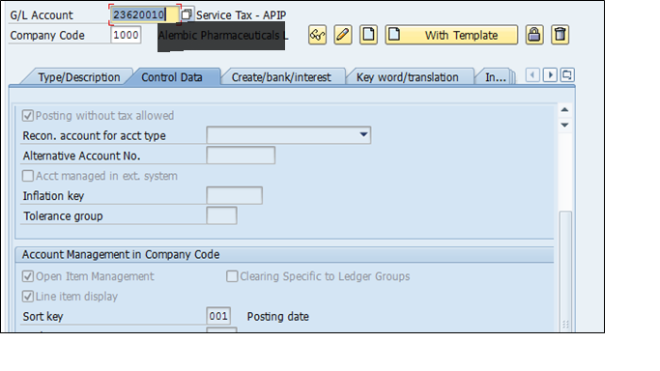](https://blogs.sap.com/wp-content/uploads/2014/06/doc1_481793.png)

In Functional point of view, it would be control all outstanding’s ,which will be receive from customer’s and pay to vendor’s / Employees / Govt.authoirities etc. in each and every line item of respective GL account reports. It should be give clear report, which line item / invoice has to be paid to vendor and received from customers. One red / Green symbol as below mentioned will be appear in standard report like FBL3N, FBL5N, and FBL1N & FAGLL03 report ,if you marked as open item management check box in GL master. Red symbol states those line items are still open and yet to clear & green symbol line items states those line items are cleared.

**Accounts to be managed as Open item management:-**

1. Bank clearing GL accounts: – All bank sub ledgers like Bank incoming payments & outgoing payment GL account must be select as open item management & it will be help us for bank reconcialtion purpose.
2. Payable GL accounts :- Like salary payable ,commission payable ,wages payable Freight payable & other tax related GL accounts like VAT payable must be select as open item management & it will be guide to FI department line item was tracking whether outstanding line items are paid to vendor’s / employees and VAT authorities or not.
3. GRIR Clearing accounts: – You easily recognize your contingency liability status of GRIR accounts, if you activated OI management.

**Process to activate the OI Management:-**

**Case 1**:- **Activate open item management for GL account with existing all line items:-**

Transaction code: – FAGL_ACTIVATE_OP

You can able to activate OI for all existing line items with using of above transaction. Let us assume there is one GL account as mentioned screen shot, which was not maintained as OI and posted several line items & now you want to activate open item management for all existing line items.

[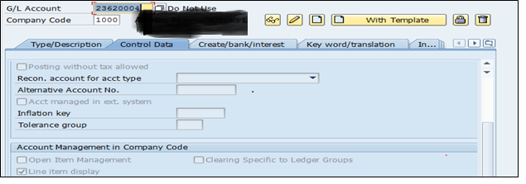](https://blogs.sap.com/wp-content/uploads/2014/06/doc2_481799.png)

FAGLL03 report view (Before activation of Open item management)

[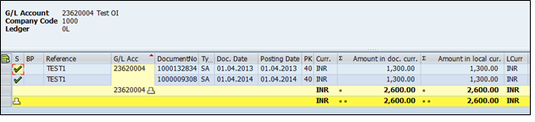](https://blogs.sap.com/wp-content/uploads/2014/06/doc3_481795.png)

Let us assume now business would like to activate all above line items as open with using of above program. Go to that transaction code & do as follows.

[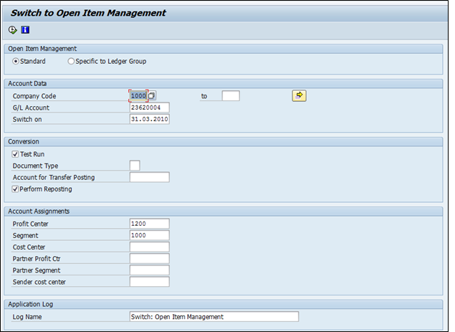](https://blogs.sap.com/wp-content/uploads/2014/06/doc4_481800.png)

Enter company code & GL account number, which is to be activating as OI & switch on date should be before the line items was posted with respect to above GL.In above case study my first document posted on 01.04.2013 ,that means switch on date should be earlier than 01.04.2013.  Document type & account for transfer posting is not required, if you enter switch on date earlier than my first document posting date & enter profit center and segment, which are mandatory & execute.

Mentioned log would shown

[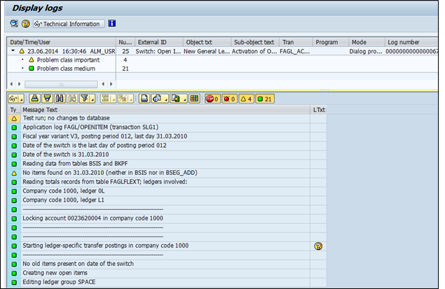](https://blogs.sap.com/wp-content/uploads/2014/06/doc5_481801.png)

Display must not be red mode, it should be green or yellow mode. Comeback from above screen & unselect test run & execute.

[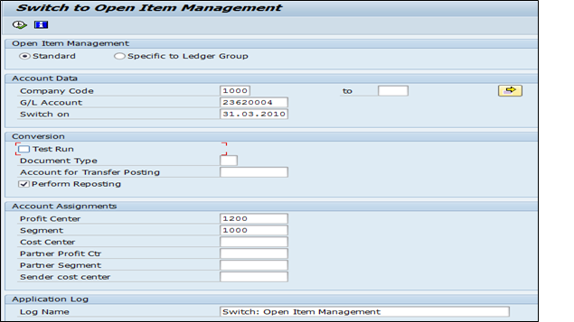](https://blogs.sap.com/wp-content/uploads/2014/06/doc6_481805.png)

[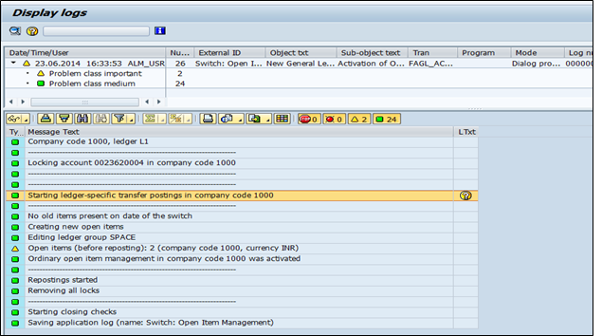](https://blogs.sap.com/wp-content/uploads/2014/06/doc7_481806.png)

Check above log ,which was given information about how many line item has been activated as open items & any transfer document posted or not. Now go to FAGLL03 & check whether line item activated as open item management and also check GL master activated for OI check box or not.

[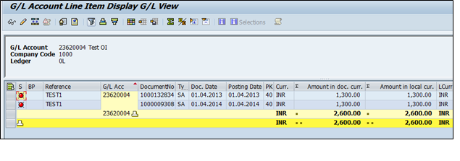](https://blogs.sap.com/wp-content/uploads/2014/06/doc_8_481807.png)

[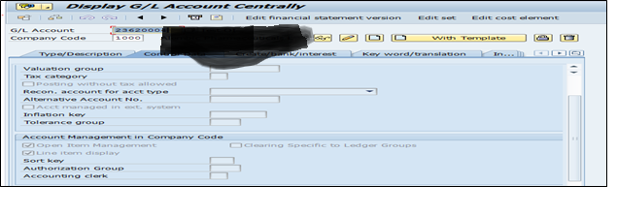](https://blogs.sap.com/wp-content/uploads/2014/06/doc9_481813.png)